Load Balancing in AWS

 We will try static scaling

 On the ec2 instances in web subnet lets have a sample web page [Refer Here](https://www.free-css.com/free-css-templates/page294/woody)  Setup:

 Lets create a vpc with 2 public and 2 private subnets

 on the ec2 instances in public subnets lets configure sample website

 This website will be hosted on 80 port and 22 port is required to ssh and install website.

Commands

sudo apt update

sudo apt install nginx unzip -y cd /tmp

wget [https://www.free-css.com/assets/files/free-css-](http://www.free-css.com/assets/files/free-css-) templates/download/page294/woody.zip

unzip woody.zip

sudo mv carpenter-website-template/ /var/www/html/woody # Now navigate to http://<public-ip>/woody



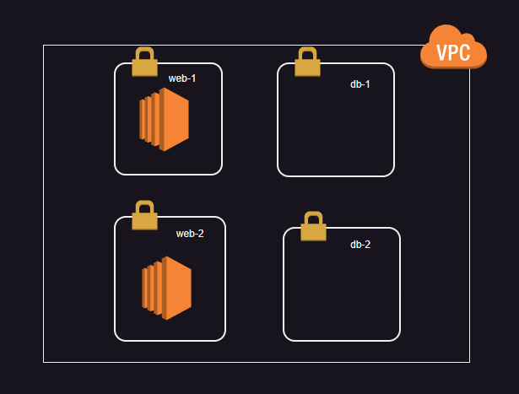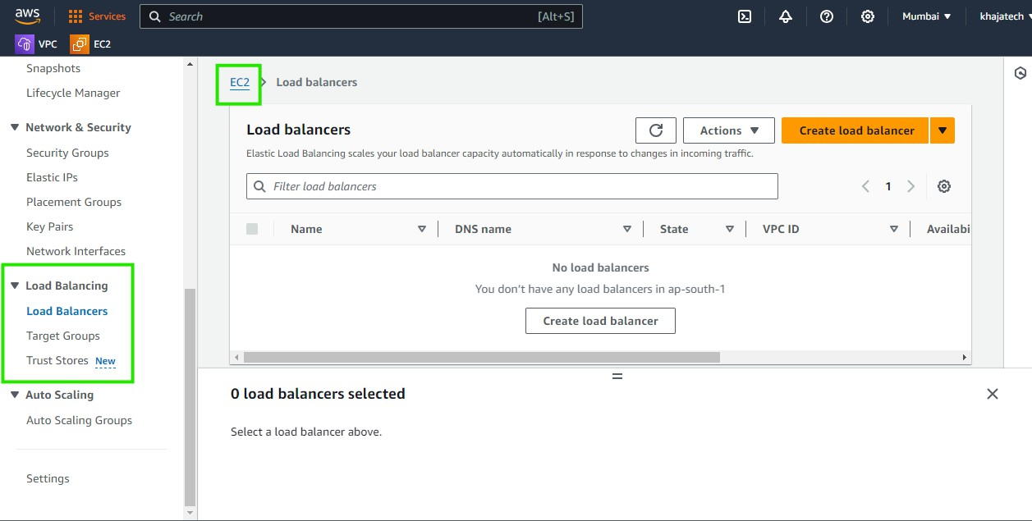We have two ec2 instances with same application

Target Groups in a load balancers section represent a set of server where the traffic has to be forwarded by the load balancer

Target group can be

 ec2 instances  ip addresses

 lamdba function

 Application load balancer

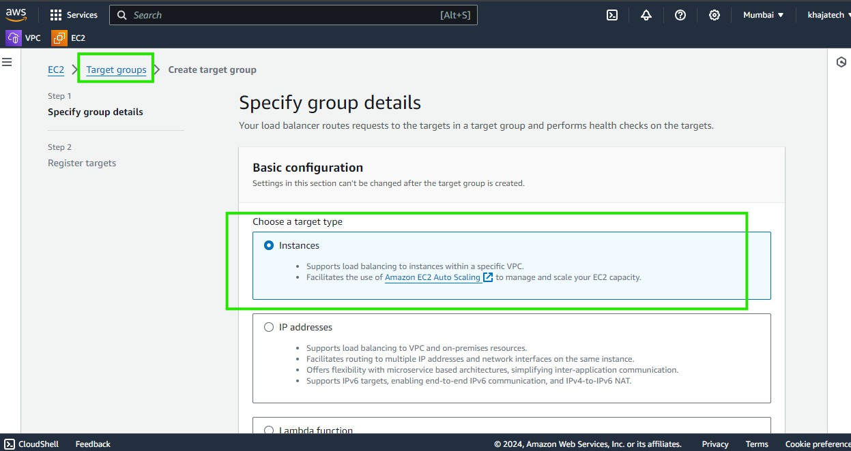Now lets create a target group with web-1, web-2 instnaces

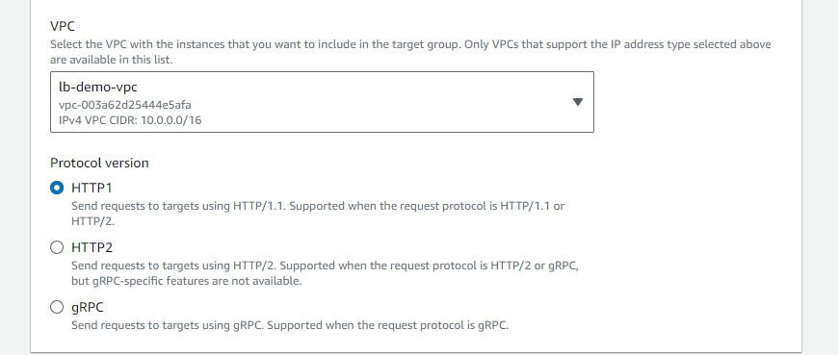

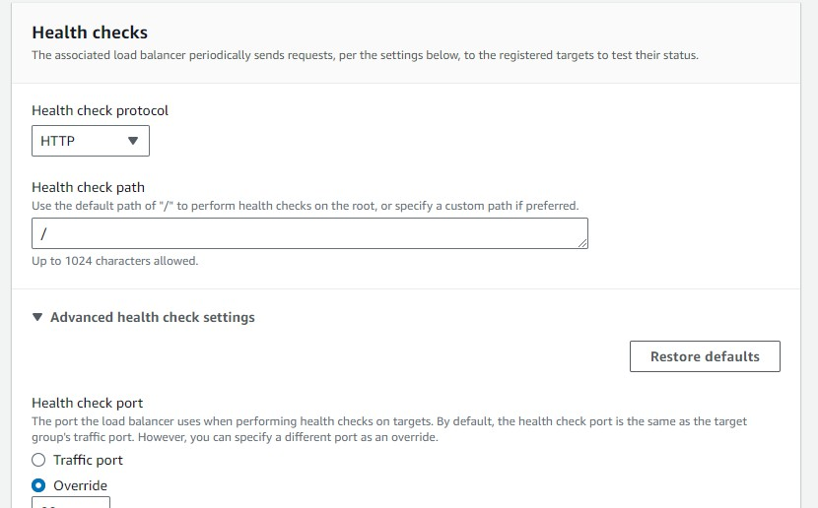

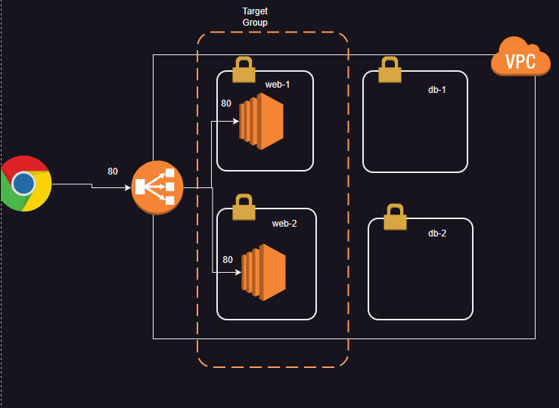 Now lets add a load balancer

 Note: view the recording for screen shots

# Lets implement Layer 4 LB with ec2 instances without public ips

 Create a vpc with 2 public and 2 private subnets  To be continued in the next session

# AWS Loadbalancer types

 AWS has the following load balancer types  Application Load Balancer:

 This is Layer 7 LB  Network Load Balancer  This is Layer 4 LB

 Gateway Load Balancer

 This is Layer 2 LB for forwarding/inspecting network traffic.

 Classic Load Balancer: This is old generation load balancer which supports both Layer 4 and Layer 7 load Balancing. Not recommended to use